SW Engineering CSC 648-848 Fall 2023

weLearn - A Comprehensive SFSU Tutoring Service

**Team 4**

**Milestone 4**

Akshat Sohal - Team Lead (email: asohal@mail.sfsu.edu) Zuriel Respicio - Frontend Lead (email: zrespicio@mail.sfsu.edu)

Charter Lin - Backend Lead Aakanksha Devarapally - GitHub Master

Andy Byeon Jorge Perez

12/11/2023

# Product summary

**Product name:** weLearn

**Product description:** Let me introduce weLearn, our web based tutoring app for San Francisco State University (SFSU) students. We're different from other tutoring services because we connect SFSU students who need help with those who've done really well in the same classes. This helps students do better in their courses and creates a supportive community at SFSU. What makes us special is our focus on helping students at our university succeed. Our app lets you get help in tough classes and gives top students a chance to become tutors. Our team has six hardworking members who work together smoothly. With leaders for the tech stuff and helpers, we stay organized with regular meetings. Come join us and discover a world of personalized help and teamwork at SFSU!

**ALL major committed functions:**

**1. Unregistered user**

○ 1.1 An unregistered user shall be able to register and become a registered user.

○ 1.2. An unregistered user shall be able to access public information on the platform without the need for authentication.

○ 1.3. Unregistered users shall have the capability to view a list of available tutors on the platform.

**● 2. Registered user**

○ 2.1. A registered user shall be able to create an account.

○ 2.2. A registered user shall have an email, username, and password

○ 2.3. A registered user shall be able to log in using email/username and password credentials.

○ 2.4. Registered user shall be able to search for SFSU classes they need help with

○ 2.5. Registered users shall have the ability to view tutor profiles.

○ 2.6. Registered users shall be able to send messages to tutors asking for appointments in person or online

○ 2.7. Registered users shall be able to apply as a tutor

○ 2.8. Registered users shall be able to post picture, resume, and optionally, a video introduction if they want to be a tutor.

○ 2.9. Registered users (if approved as tutor) shall be able to receive messages from student asking for tutoring

**● 3. Admin**

○ 3.1. Admins shall be required to review and approve or reject tutor profiles.

○ 3.2. Admin shall be required to remove inappropriate or offensive content from the platform.

○ 3.3. Admin shall be able to access tutor profiles, resumes, profile pictures, and videos.

○ 3.4. Admin shall be able to access student username, email, and profile picture.

**What is unique in our product:** What makes our product unique is that it's made specifically for SFSU students. It connects students who need help with others who did well in the same courses, creating a supportive community. Our app is easy to use, letting students schedule tutoring sessions that fit their schedules. Plus, it follows SFSU rules, making it safe and reliable. Also, it gives students a chance to become tutors themselves, making it a helpful learning tool and a way to give back to the community at the same time.

**Product URL:** [**http://54.219.143.67/**](http://54.219.143.67/)

# Usability test plan:

Major function selected: *search*

**Test objectives:**

The purpose of this usability test is to evaluate the effectiveness and user-friendliness of the search feature within weLearn, our tutoring app tailored for San Francisco State University (SFSU) students. By assessing how easily users can find and connect with tutors based on specific courses, this test aims to identify potential issues and gather feedback to enhance the search experience.

**Test background and setup:**

* **System setup:** The test will take place in an environment equipped with a computer or mobile device connected to the internet, using a commonly used web browser.
* **Starting point:** Testers will begin their exploration from the platform's main page, which serves as the homepage, aiming to locate and use the "Search" feature.
* **Who are the intended users:** The intended users of our product are for SFSU students who need tutoring or who want to help as tutors. Testers should know how to use the internet to check the web.
* **URL of the system to be tested:** [**http://54.219.143.67/**](http://54.219.143.67/)
* **Test environment:** Testing can take place either in a controlled lab environment or at the convenience of the user's home. Importantly, no prior training is necessary for participants, allowing a more natural and unbiased evaluation of the platform's usability. We may also use monitoring tools to observe how users interact with the platform, ensuring a better understanding of their experience.

**Plan for evaluation of Effectiveness:** Effectiveness assessment will center on task success rate, quantified as the percentage of users who proficiently locate a tutor via the "Search" function within a designated time frame. These tasks encompass searching by tutor name, subject, and specific class name. The objective is to evaluate the platform's navigational efficiency and user-friendliness in facilitating users to locate pertinent tutoring assistance.

**Plan for Evaluation of efficiency:** The evaluation of efficiency will involve assessing the duration taken by users to accomplish individual tasks. This meticulous analysis aims to gauge the expediency and user-friendly nature of the "Search" function in locating a suitable tutor. The focus lies in quantifying the time required for users to navigate the platform effectively, providing valuable insights into the speed and ease of use inherent in the tutoring app's search feature.

**Plan for Evaluation of user satisfaction (Likert scale questionnaire):**

**A)** **Usability Task description:**

**Task 1:** Searching for Tutor by Name

**Instructions:** “Utilize the 'Search' function to locate a tutor named 'Jhon' Once located, proceed to click on the profile of this specific tutor.”

**Task 2:** Searching for Tutor by Class

**Instructions:** “Use the 'Search' function to find a tutor offering guidance for the 'Physics 111' class. Click on the profile of the tutor associated with teaching this particular course.”

**Task 3:** Searching for Tutor by Subject

**Instructions:** “Employ the 'Search' function to find a tutor specializing in 'Math' Click on the profile of the first tutor listed in the search results.”

**B)** **Likert scale evaluation entries:**

Task 1 Linkert Entry: Searching for Tutor by Name

“Process of locating the tutor named 'Jhon' using the 'Search' function is easy and intuitive.”

○ Strongly Disagree ○ Disagree ○ Neutral ○ Agree ○ Strongly Agree

Task 2 Linkert Entry: Searching for Tutor by Class

“Process of finding a tutor for the 'Physics 111' class using the 'Search' function is efficient.”

○ Strongly Disagree ○ Disagree ○ Neutral ○ Agree ○ Strongly Agree

Task 3 Linkert Entry: Searching for Tutor by Subject

“Process of finding a tutor specializing in 'Math' using the 'Search' function is easy and intuitive.”

○ Strongly Disagree ○ Disagree ○ Neutral ○ Agree ○ Strongly Agree

Each entry provides a range of responses from "Strongly Disagree" to "Strongly Agree," allowing

users can express their level of agreement or disagreement with the given statements, reflecting their experience with the respective tasks in the app.

# QA test plan and QA testing:

**Test objectives:**

This QA test plan aims to validate the functionality, usability, and performance of the “Search” function within the weLearn tutoring app. The test cases cover specific scenarios to verify the accuracy of search results based on tutor name, class number, and subject inputs, with successful outcomes recorded for both major browsers, Google Chrome and Mozilla Firefox.

**HW and SW setup (including URL):**

Hardware: Standard computer or mobile device.

Software: WWW browsers (Google Chrome and Mozilla Firefox)

URL: <http://54.219.143.67/>

**Feature to be tested:** Utilize the "Search" function to explore tutors by specifying criteria such as their name, class number, and subjects available exclusively through the dropdown menu.

| **Test** | **Test title** | **Test Description** | **Test input** | **Expected Correct Output** | **Test results (Google Chrome)** | **Test results (Mozilla Firefox)** |
| --- | --- | --- | --- | --- | --- | --- |
| **1** | Search by name | The user has to use the search function to locate a tutor by its name | Type “Jhon” on the search field | Get 1 results, all  have “Jhon” in name field | PASS | PASS |
| **2** | Search by class number | The user has to use the search function to locate tutor/s by the class number | Type “Physics 111” on the search field | Get 2 results, all  have “Physics 111” in course field | PASS | PASS |
| **3** | Search by subject | The user has to use the search function to locate tutor/s by subject | Making use of the dropdown menu, select “Math” | Get 1 results, all  have “Math” in subject field | PASS | PASS |

# Peer Code Review:

**Email Requesting Code Review:**  
**Sent from:** [jperezmora@sfsu.edu](mailto:jperezmora@sfsu.edu)

**Sent to:** [zrespicio@sfsu.edu](mailto:zrespicio@sfsu.edu)

**Sent email:**  
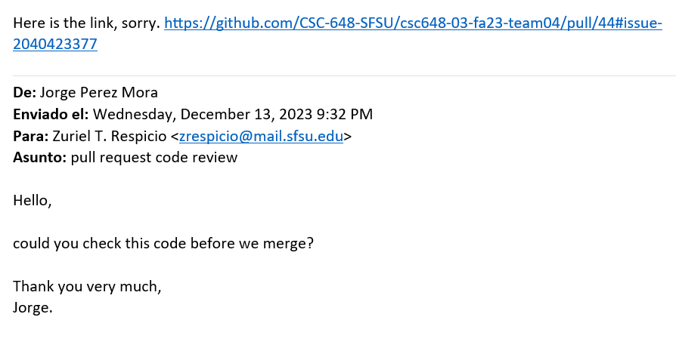

**Link of the pull request:**

<https://github.com/CSC-648-SFSU/csc648-03-fa23-team04/pull/44>

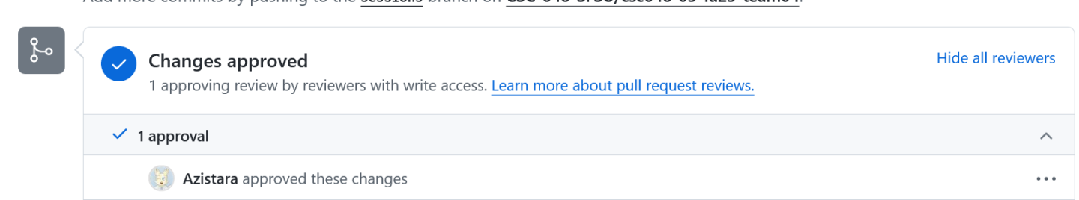

**Sent from:** [jperezmora@sfsu.edu](mailto:jperezmora@sfsu.edu)

**Sent to:** [zrespicio@sfsu.edu](mailto:zrespicio@sfsu.edu)

**Response email:**

# 

# Self-check on best practices for security – ½ page

| **Asset to be protected** | **Types of possible/expected attacks** | **Your strategy to mitigate/protect the asset** |
| --- | --- | --- |
| SFSU User Registration Email | Security Logging and registering, Injection attacks | Mitigate unauthorized access by verifying that registered emails belong to the institution (sfsu.edu), enhancing security and limiting access to authorized users. Restrict characters to valid email format to prevent injection of malicious scripts or commands. |
| Search Function Input | Injection attacks | Limit input to 40 alphanumeric characters to reduce the risk of injection attacks by limiting input size. |
| User Password | Password cracking, brute force attacks | Store passwords using strong encryption methods and ensure robust key management to prevent unauthorized decryption. Enforce complex password requirements to resist brute force attacks. |
| Tutors Application | Content review, Detection of Suspicious Activity | Employ admin review and approval for uploaded content to ensure it meets standards of adequacy, friendliness, and respectfulness, maintaining the application's reputation and user experience. Regularly review access logs specific to Tutors content to detect and respond to any suspicious activity or breaches, ensuring timely identification and mitigation of potential security issues. |

# Self-check of the adherence to original Non-functional specs – performed by team leads

|  | **Non-Functional Requirements** | **Status** |
| --- | --- | --- |
| **1** | Application shall be developed, tested and deployed using tools and servers approved by Class CTO and as agreed in M0 | ON TRACK |
| **2** | Application shall be optimized for standard desktop/laptop browsers e.g. must render correctly on the two latest versions of two major browsers | ON TRACK |
| **3** | All or selected application functions shall render well on mobile devices | ON TRACK |
| **4** | Data shall be stored in the database on the team’s deployment server. | ON TRACK |
| **5** | No more than 50 concurrent users shall be accessing the application at any time | ON TRACK |
| **6** | Privacy of users shall be protected | DONE |
| **7** | The language used shall be English (no localization needed) | DONE |
| **8** | Application shall be very easy to use and intuitive | DONE |
| **9** | Application shall follow established architecture patterns | ON TRACK |
| **10** | Application code and its repository shall be easy to inspect and maintain | ON TRACK |
| **11** | Google analytics shall be used | DONE / ON TRACK / ISSUE |
| **12** | No e-mail clients shall be allowed. Interested users can only message to sellers via in-site messaging. One round of messaging (from user to seller) is enough for this application | ON TRACK |
| **13** | Pay functionality, if any (e.g. paying for goods and services) shall not be implemented nor simulated in UI. | ON TRACK |
| **14** | Site security: basic best practices shall be applied (as covered in the class) for main data items | ON TRACK |
| **15** | Media formats shall be standard as used in the market today | DONE |
| **16** | Modern SE processes and tools shall be used as specified in the class, including collaborative and continuous SW development | ON TRACK |
| **17** | The application UI (WWW and mobile) shall prominently display the following exact text on all pages *"SFSU Software Engineering Project CSC 648-848, Fall 2023. For Demonstration Only”* at the top of the WWW page nav bar. (Important so as to not confuse this with a real application). | ON TRACK |